Gender Verification in Sports
Name of the Student
Institution Affiliation
Course
Date

Question 1
Caster Semenya is a young female athlete from South Africa., a country found in Africa. Semenya emerged as the winner of the 800m in the World Championships that were held in the year 2009. In this case, Semenya is obliged to go for a gender testing whereby she gets withdrawn temporally from the international competition.
Political map of South Africa
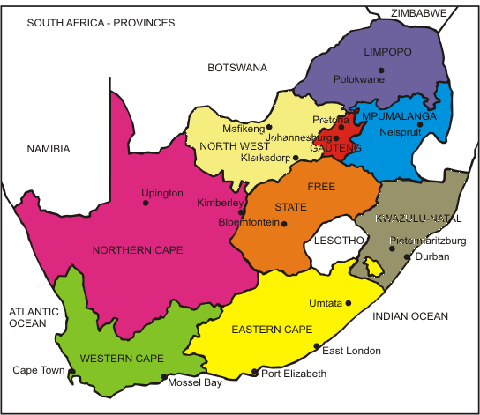
(Butler, 2017).
A political map of Africa
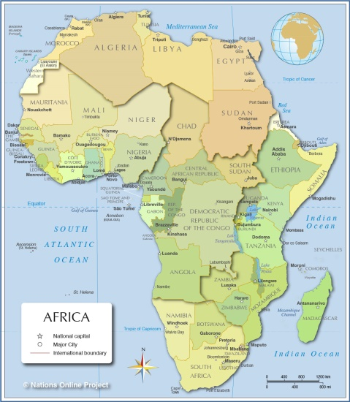
(Davidson, 2014).
The sporting event was the World Championship which held international competitions and it took place in Leichtathletik-Weltmeisterschaften, Berlin in Germany in the year 2009.
Political Map of Germany
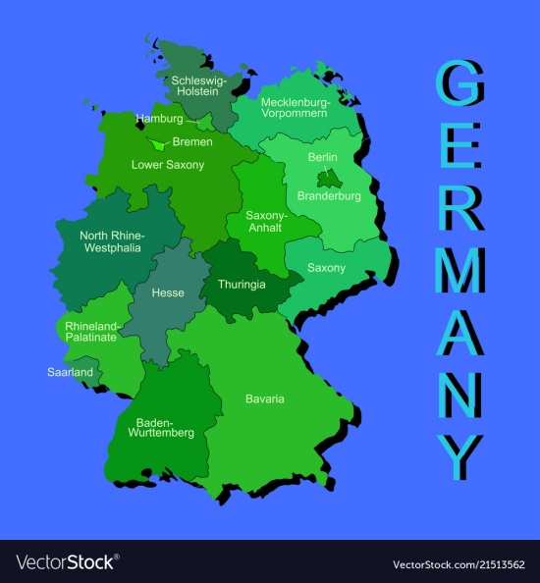

(Van Deth, 2014).
Political Map of Europe
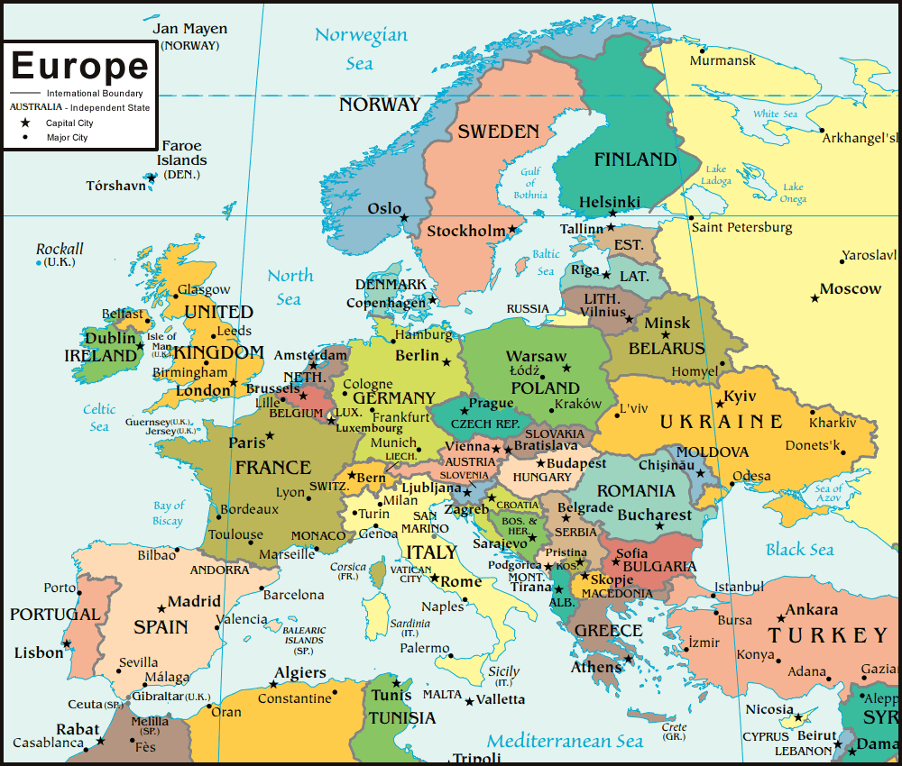 (
(Marsh, 2016).
Question 2
In relation to the controversy and the reaction of the disqualification of Caster Semenya after going for a gender testing whereby she gets withdrawn temporally from the international competition, her country reacted by showing disbelieve of the news. This is because the news came as they were not anticipated. As a hometown as well as a country, they were hoping that Caster Semenya was going to be celebrated as the winner of the 800m in the World Championships that were held in Germany but instead they got the news that was shocking as well as dispersing. They had all believed in Caster Semenya and according to their expectations, she was going to make them proud but instead they got disgusting news. Moreover, the hometown and country of Caster Semenya reacted by showing a lot of sympathy to her regarding her temporarily disqualification from the international competition despite the fact that she had proven her intelligence by emerging as the winner of the event. Also, the cultural environment of Caster Semenya was not supportive. This is as a result of the hidden implication that was consisted in saying that Semenya had failed in complying with the femininity standards, thus she cheated because she was a man, together with the assumption that men are considered to be more superior when compared to women (Kidd, 2013).
If Caster Semenya was from my culture, the reaction is likely going to be different. It can be different on the way we are going to react since we will be overwhelmed with joy after her winning but when we come to terms that she has been cheating on her gender we will all turn away from her and everyone is going to lose interest and also to develop a negative attitude towards her. This is likely going to happen because she will have shown disloyalty to our country by portraying such a bad replica of our country. Sex verification in sports has emerged as the most essential and important test done during sports because the eligibility of the athletes who are participating is very significant. On basing my argument on the way sex determination is done today in sports, there are many cases that are concerned with mistakes that can be said to be honest, but not fraud cases which are derived from the results (Hull et al, 2014).
Question 3
According to the video, a person's sexual chromosomes, as well as anatomy, are likely not going to match when there is a disagreement between the body and the brain. In a situation where a child has inherited a Y from his father as one of the chromosomes, the child is likely going to be a male. When it comes to transgender people, the genetics and the identity that is based in the brain are not likely going to math. This means that when there is a share of half of each chromosomal pair with the offspring, the sex chromosomes offered by the parents will always be an X (Cooky et al, (2013). In relation to the video, a female could have XY chromosomes which in many cases happen when the girl is experiencing androgen insensitivity syndrome, while the male experiences XX chromosomes as a result of the crossover which occurs between the X and Y chromosomes outside of the pseudoautosomal region during Meiosis 1. In this case, there is the transfer of the SRY of the Y chromosomes to those of the X chromosomes, such that testicular rather than the occurrence of the ovarian development (Shank et al, 2014).
Reference
Butler, A. (2017). Contemporary South Africa. Macmillan International Higher Education.
Cooky, C., Dycus, R., & Dworkin, S. L. (2013). “What Makes a Woman a Woman?” Versus “Our First Lady of Sport” A Comparative Analysis of the United States and the South African Media Coverage of Caster Semenya. Journal of Sport and Social Issues, 37(1), 31-56.
Davidson, B. (2014). Modern Africa: A social and political history. Routledge.
Hull, K., & Lewis, N. P. (2014). Why Twitter displaces broadcast sports media: A model. International Journal of Sport Communication, 7(1), 16-33.
Kidd, B. (2013). Sports and masculinity. Sport in society, 16(4), 553-564.
Marsh, A. (2016). Political Action in Europe and the USA. Springer.
Shank, M. D., & Lyberger, M. R. (2014). Sports marketing: A strategic perspective. Routledge.
Van Deth, J. W. (2014). A conceptual map of political participation. Acta Politica, 49(3), 349-367.

